**Exercise 1: Mocking and Stubbing**

**Scenario:**

You need to test a service that depends on an external API. Use Mockito to mock the external API and stub its methods.

**Steps:**

1. Create a mock object for the external API.
2. Stub the methods to return predefined values.
3. Write a test case that uses the mock object.

**Solution Code:**

import static org.mockito.Mockito.*;

import org.junit.jupiter.api.Test;

import org.mockito.Mockito;

public class MyServiceTest {

@Test

public void testExternalApi() {

ExternalApi mockApi = Mockito.mock(

ExternalApi.class

);

when(mockApi.getData()).thenReturn("Mock Data");

MyService service = new MyService(mockApi);

String result = service.fetchData();

assertEquals("Mock Data", result);

}

}

**Exercise 2: Verifying Interactions**

**Scenario:**

You need to ensure that a method is called with specific arguments.

**Steps:**

1. Create a mock object.
2. Call the method with specific arguments.
3. Verify the interaction.

**Solution Code:**

import static org.mockito.Mockito.*;

import org.junit.jupiter.api.Test;

import org.mockito.Mockito;

public class MyServiceTest {

@Test

public void testVerifyInteraction() {

ExternalApi mockApi = Mockito.mock(ExternalApi.class);

MyService service = new MyService(mockApi);

service.fetchData();

verify(mockApi).getData();

}

}

**SOLUTION CHECKLIST (COMBINED EX_1 & EX_2)**

1. Interface/class ExternalApi created with a method getData()
2. Class MyService implemented with:
   1. Constructor that accepts an ExternalApi instance
   2. Method **fetchData**() that calls **externalApi.getData**()
3. Test class **MyServiceTest** created under **src/test/java/com/cognizant**

🧪 Exercise 1: **Mocking and Stubbing**

1. In **testExternalApi**():
   1. Created mock object using **Mockito.mock**(ExternalApi.class)
   2. Stubbed **getData**() to return "Mock Data" using **when**(...).**thenReturn**(...)
   3. Created a **MyService** instance using the mock Called **fetchData**() and asserted result with:

**assertEquals**("Mock Data", result);

🧪 Exercise 2: **Verifying Interactions**

1. In **testVerifyInteraction**():
   1. Created mock object of **ExternalApi**
   2. Passed it to **MyService** and called **fetchData**()
   3. Verified interaction using:
      1. **verify**(mockApi).getData();
2. Required imports added:

import static org.mockito.Mockito.*;

import static org.junit.Assert.assertEquals;

import org.junit.Test;

1. Tests executed using mvn test and passed successfully

**OUTPUT**

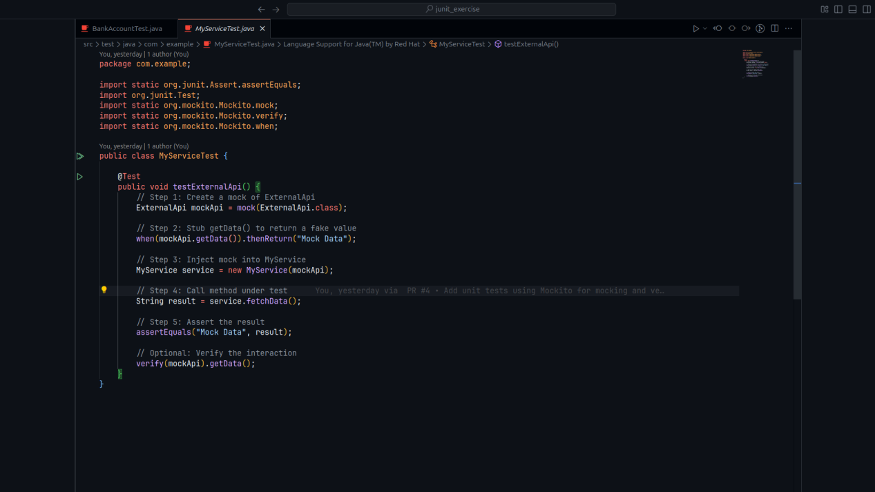

**RUNNING TEST**

